Project Proposal

**Project Proposal**

- **Overview:** a simple game application where user controls a SongBird. This songbird can fly up and down. The goal is to last as long as possible. There are blackbirds.if the player hits a blackbird, they die and the game ends. The longer they last the higher their score will get.

- **Product Purpose:**

a. ***Target audience****: Kids on the age below 13*

b. ***Reasoning of how your project demonstrates creativity :***

it has interesting good visual, a good animation, its fun to play.

- **Features:**

**1. Moving background**

In order to get this game started, we first implement a moving background to give players the illusion that they are moving forward, despite they are actually in the same position. This is done by moving the background slowly to the left. There will be 2 backgrounds. The second background will be placed when the screen ends in the x axis. This will be repeated over and over until the game ends

**2. Player control over songbird**

Player can move the songbird up and down, this is done by holding the left screen and letting it go with their thumb. if user hold the left screen, songbird will go up

if user let go of the screen, songbird will go down.

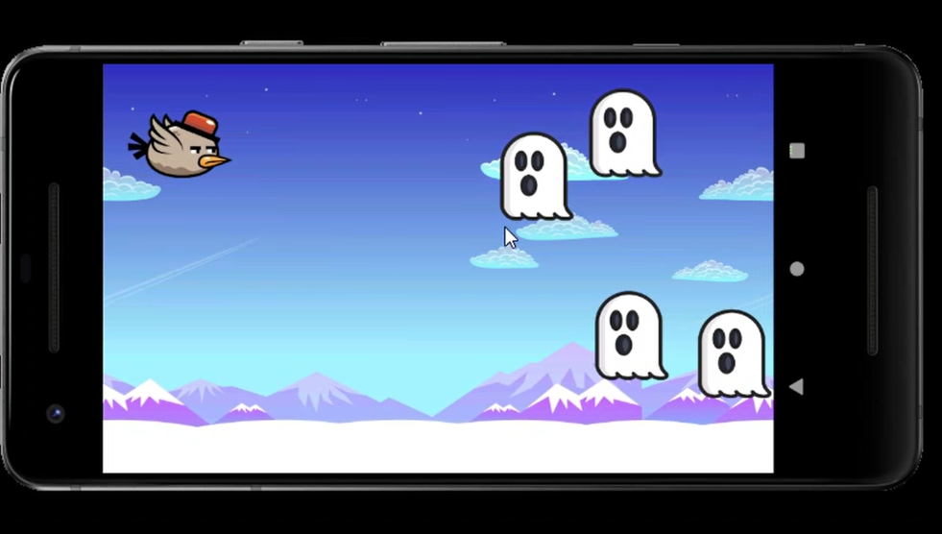

**3. Shooting Mechanic**

Right screen is pressed in order for songbird to shoot

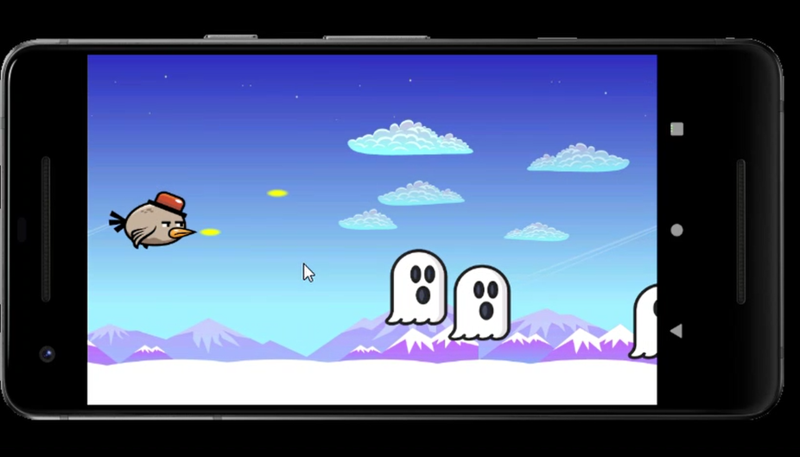

**4. Ghost**

Ghost will spawn from right end of the screen towards the player. If ghost hits the songbird, the songbird dies.

- **Design:**

The app opens with a main menu

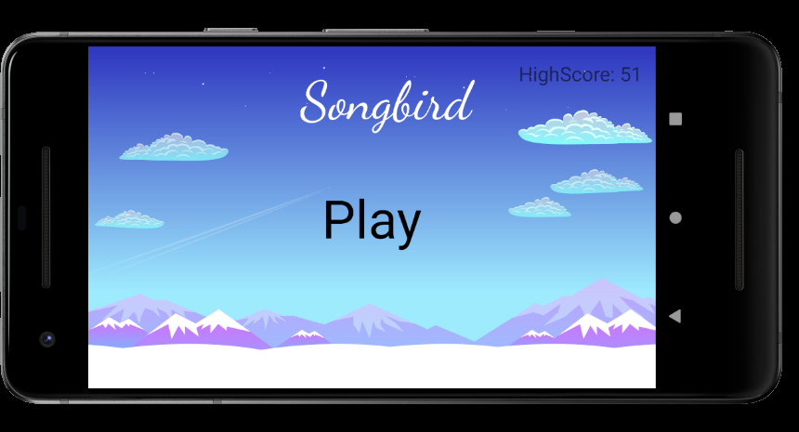

The highest score that the player achieved so far is placed at the top right of the screen. The game starts when the play button in the center of the screen is pressed

- **Data:** A top-level overview of the data tables/structures you will store in your

app. This will include both:

1. **Runtime Variables**

* High scores will be stored, the longer the player last, the higher their score gets.
* if the player get hits by a blackbird, the game ends
* If the player miss, the game ends

**b. Permanent Storage Data** (fixed data from disk storage / local database).

High score will be permanent, if player reach a higher score, the older score will be replaced

- **API/Class Structure:**

There are 7 classes

1. Background class

* Constructor

Has a constructor that take the size of the screen on the x and y axis. It takes resource object to decode bitmap from drawable folder

1. Bullet Class

* Constructor

Take width and height of bullet and resize it to make it compatible to the screen

* getCollisionShape

make a rectangle object around the bullet, this is to identify if bullet collides with a ghost or not

1. Game activity

* OnCreate
* Set activity to fullscreen
* OnPause
* Pause the game when activity is paused
* OnResume
* Resume the game when activity resumes

1. Game view class

* Constructor
* Basically this is used to declare and initialize objects(e.g ghost and bullet objects)
* Run
* This function creates a loop while the game is still playing. Inside the loop, it calls update, draw and sleep method
* Update
* Make background compatible to the phone screen, background will be move by 10 pixel towards the left. Soon our background will go off screen, at that time, we place the background again after the screen ends
* Avoid songbird from going offscreen. if bird reach the top of the screen, then set the birds y axis to 0, so that it stays on screen. if bird goes offscreen from the bottom, set the bird to stay at the bottom of the screen
* Check if bullet goes offscreen
* Check if bullet collides with ghost
* Add score if bullet hits a ghost
* Set the game to be over if the bird and ghost collides.
* Draw
* Draw background on the canvas
* Draw ghost
* Display high score
* Draw songbird
* Draw bullets
* Sleep
* Enable the game to run in 60 frames per second by making the game wait for 17 milliseconds. When 1 second is divide by 17 it returns 60.
* Resume

Start the thread

* Pause

Pause the game when its called

* OnTouchEvent
* Has a switch case that will take action based on the use. if user takes his thumb off ,bird will go down. If user hold left screen the bird will go up.
* saveIfHighscore
* Save the high score record of the player. If player gets a higher score, the record will be replaced
* waitBeforeExiting

- put thread to sleep for 3 seconds

- set an intent to change from gameview activity to main activity

* newBullet
* set position of where the bullet is going to come from
* add new bullet into the list

1. Ghost class

* Constructor
* Constructor accepts resources
* Declare and initialise bitmap object for the animation
* Resize the ghost to make it compatible for the phone screen
* getGhost
* create an animation for the ghost
* getCollisionshape
* creates a rectangle object around the ghost to detect collision

1. Main activity

* onCreate
* make main activity fullscreen
* start the game when play button is clicked
* show the high score of the game

1. Songbird class

* Constructor
* Constructor accepts resources
* Declare and initialise bitmap object for the animation
* Resize the bird to make it compatible for the phone screen
* getBird
* check if there is a bullet to be shot
* create an animation
* getDead
* return a bitmap of a dead songbird if the bird hits a ghost
* getCollisionShape
* creates a rectangle object around the songbird to detect collision

- **Resources Required (optional):**

Image for the background

snowymountains by waldo

License: Creative commons

<https://pressstart.vip/assets>

Image used for the player songbird

Water Bird by Shashkov Yuri

License: Personaal use only

Image is used as the enemies ghost

Ghost transparent background PNG clipart from HiClipart

Non-Commercial Use, no attribution required